Chapter 4: Rational Functions and Conics
4.1 – Rational Functions and Asymptotes
A rational function can be written in the form:
$$f\left(x\right)=\frac{p(x)}{q(x)}$$
where $p\left(x\right)$ and $q(x)$ are ______________________________ and $q(x)$ is not the _________
polynomial.

In this section, we assume that $p\left(x\right)$ and $q(x)$ have no ________________________________.
In general, the domain of a rational function of $x$ includes ________ _____________________
except $x-values$ that make ____________________________________________________.

Much of our discussion of rational functions will focus on their graphical behavior near these $x-values.$

FINDING DOMAIN OF A RATIONAL FUNCTION
Find the domain of $f\left(x\right)$ and discuss the behavior of $f$ near any excluded $x-values.$

$f\left(x\right)=\frac{1}{x}$

To determine the end behavior of $f$ near this excluded value, evaluate $f(x)$ to the left and right of $x=$ ______.
To the left of _____
$$x$$ | $$-1$$ | $$-0.5$$ | $$-0.1$$ | $$-0.01$$ | $$-0.001$$ | $$→0$$
$$f(x)$$

To the right of _____
$$x$$ | $$0←$$ | $$0.001$$ | $$0.01$$ | $$0.1$$ | $$0.5$$ | $$1$$
$$f(x)$$

As $x$ approaches 0 from the left, $f(x)$ ________________ without bound, whereas as $x$ approaches 0 from the right, $f\left(x\right)$ ________________ without bound.
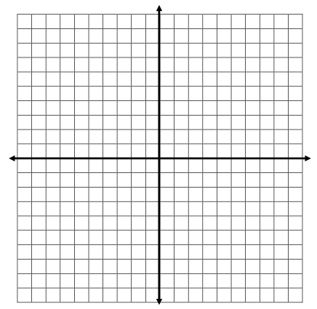
THE GRAPH OF $f\left(x\right)=\frac{1}{x}$

The line _______________ is a ______________________________________ of the graph $f$.
The graph of $f$ also has a ______________________________________ – the line _________.

Examples: Find the domain of the following rational functions.
- $f\left(x\right)=\frac{1}{x+1}$ b. $f\left(x\right)=\frac{3x^{2}}{x^{2}-9}$ c. $f\left(x\right)=\frac{5x}{x^{2}+3x-10}$

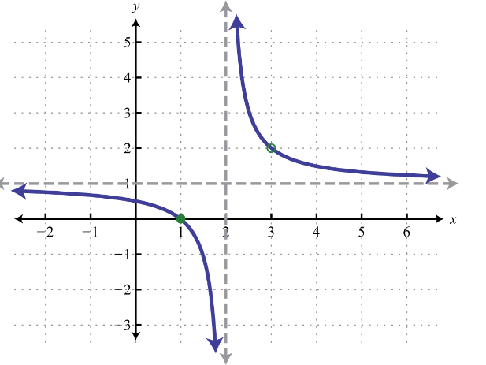
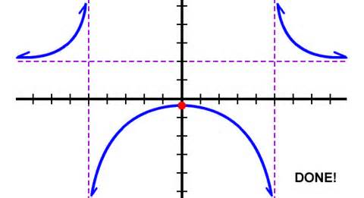
d. e.

ASYMPTOTES OF RATIONAL FUNCTIONS
Vertical Asymptote - ___________________________________________________________
**Solve by finding zeros of the denominator by setting the denominator equal to 0.**
The vertical asymptotes are the x-values that are excluded from the domain.
$$f\left(x\right)=\frac{4}{x+2}$$

Horizontal Asymptote - _________________________________________________________
Find the horizontal asymptotes by using the following rules of the degrees of $p(x)$ and $q(x)$.
Rule #1: If the numerator has the higher degree (exponent), there is NO horizontal asymptote.
$$f\left(x\right)=\frac{2x^{3}}{3x^{2}+1}$$
If we divide out the degree, we can determine the end behavior of the graph.

Rule #2: If the denominator has the higher degree (exponent), $y=0$ is the horizontal
asymptote.

$$f\left(x\right)=\frac{2x}{3x^{2}+1}$$

Rule #3: If the degree (exponent) is the same in both the numerator and denominator, then
the equation of the horizontal asymptote is the quotient of the leading coefficients of both the numerator and denominator.

$$f\left(x\right)=\frac{2x^{2}}{3x^{2}+1}$$

Find all vertical and horizontal asymptotes of the following functions.

- $f\left(x\right)=\frac{2x^{2}+1}{x^{2}- 1 }$ b. $f\left(x\right)=\frac{x^{2}- x - 2}{x^{2}- x - 6}$

c. $f\left(x\right)= \frac{4}{{(x-3)}^{3}}$ d. $f\left(x\right)=\frac{5x^{2}}{x+1}$

e. $f\left(x\right)=\frac{6x}{x^{2}- 8x + 16}$ f. $f\left(x\right)=\frac{x^{3}}{x - 1}$

